SPONSOR PROFILES
The 4th TIC-TAC-TOE PLAYING ROBOT CONTEST - 2021
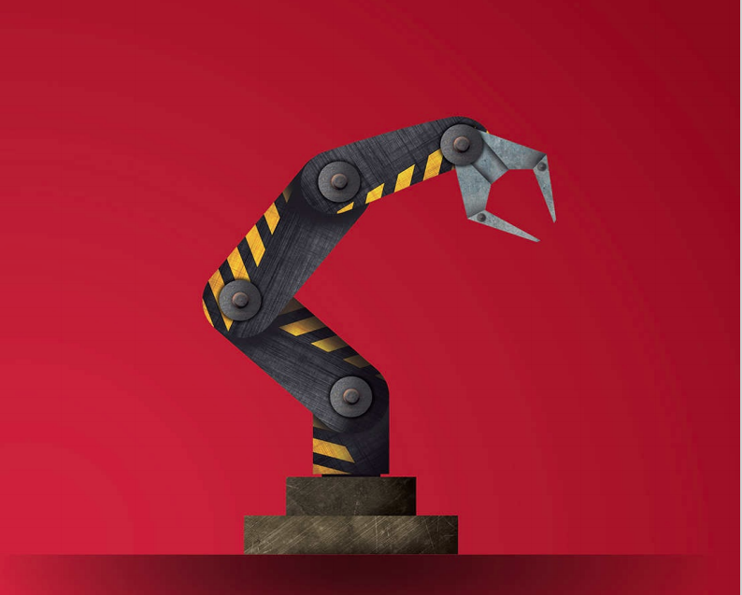

 | Gate to Future
OPEN LETTER
Firstly, we would like to send all our best wishes and warmest greetings to you and your company. We wish you futher success in your business in the future.
At the beginning, in the hope of being exhibited of all the results of students’s studying and scientific - researching process throughout the period of studying project based learning at the Hochiminh City Univerity of Technology and Education. In addition, this is also to build up the inquiring mind, promote the achievements of students as well as to form an exchange space not only among all students in Faculty of Mechanical Engineering but also between the our in-coming graduate students and the employers.
We are the oganization board who will perform the “Tic-Tac-Toe Playing robot contest” of all students in the Hochiminh City University of Technology and Education. This is going to be a great opportunity for our students to exchange their mind with Business Enterprises and share the achievements with their teachers, family and friends. Consequently, the corporation between the Organization board and the Sponsors is able to contribute the improvement of quality of human resources for our society in near future.
These are the reasons why we send to you this Open letter in the hope of receiving your supports about the expenditure and presents as well as good conditions to successfully organize the “Tic-Tac-Toe Playing robot contest”. As the result of this event, it is going to warm up the desire to study and work in the younger generration in order to develop the Vietnam’s high-tech human resources.
Yours faithfully,
Head of Organization Board

Prof, PhD. Nguyen Truong Thinh

ORGANIZATION CONTEST PLANNING
PURPOSES:
- Celebrating the Independence Day 2021; encourage scientific research and robot creativity of HCMUTE students. Thus Faculty of Mechanical Engineering oganizes the “Tic-Tac-Toe Playing Robot” contest and exhibit the robot made by students in recently.
- Improving mental exchange of students learning among the students of Mechanical Engineering Faculty at the Hochiminh City University of Technology and Education.
- Promoting the achievements and enhance the pride of the outcomes that the students were harvested during the study period at the university.
- Creating conditions to help students understanding the needs and the standard human resource in business. Therefore, students can add additional skills to meet the employment requirement of the business.
- Finding the lasting solutions to improve the ability to apply the scientific research of student in life.
- Establishing the relationships between the university and the society to transfer the scientific research results of students to the society.
- Creating learning atmosphere in the universities and thereby enhance the self-awareness learning as well as scientific research for all students of University of Technical Education Hochiminh City.
- Creating learning and exchanging playground for students.

CONTENTS:
- Organizing the “Tic-Tac-Toe Playing Robot” contest for students of HCMC University of Technology and Education.
- Exhibiting the typical robot products.

PARTICIPANTS:
- All of student of HCMUTE who love robot can enroll the contest.
- Student registers in team or individual with humanoid robot form required.
RULES:
Playing Tic-Tac-Toe is a game that is very favorite to each of us especially pupils and students. Tic-Tac-Toe Game is not only for entertainment, but also for a brain’s game. The playing robot contest aims to apply artificial intelligence to the robot to show your robot design skills and the level of your designed controller.
- Chess piece: In the game, the X / O symbol is used, which is displayed when the pen is attached to the end of the End-effector and piles up on the touch screen.
- Caro chess board
• Use a 3 × 3 board (square) in preliminary round, (5x5) semi-finals and 7x7 finals.
• Only 2 robots are allowed per chess board to participate.
• Robots can be pre-programmed or embedded with online play software to control the movement of the pen.
• When the robot has finished its own move, it must return to its home position, not obstructing the movement of the opponent robot.
• Round of play (tick X / O)
• In a game, 2 robots are randomly chosen to choose the first team, the first robot will have an X mark, and the second robot will be an O.
• There is a AC power supply - 220V.
TIME AND PLACE:
The contest will be shown on only one day, from 6:00 PM to 9:00 PM, May 29th 2021 at the outdoor stage in front of the lobby of Hi-Tech Center of HCMUTE.
Planning Table

Time  (expected) | Content | Note
6 PM – 6.15 PM | Opening Contest, introducing guests, examiner  Speech of the organizing committee
6.15 PM – 6.30 PM | Opening entertainment
6.30 PM – 7 PM | First round
7 PM – 7.15 PM | Robot’s show
7.15 PM – 7.45 PM | Second round
7.45 PM – 8 PM | Entertainment
8 PM – 8.30 PM | Final round
8.30 PM – 9 PM | Awarding and Closing

EXPECTED FORM DESIGN:
BACKDROP/ VERTICALLY BANNER

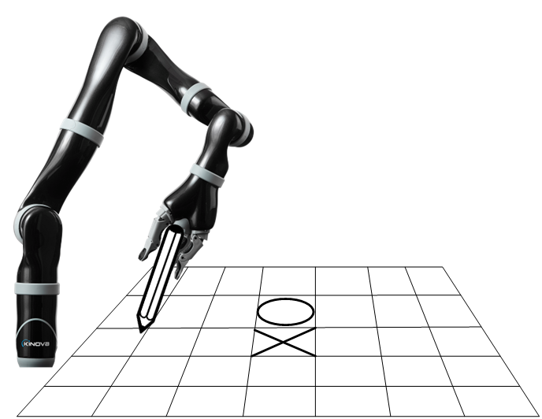

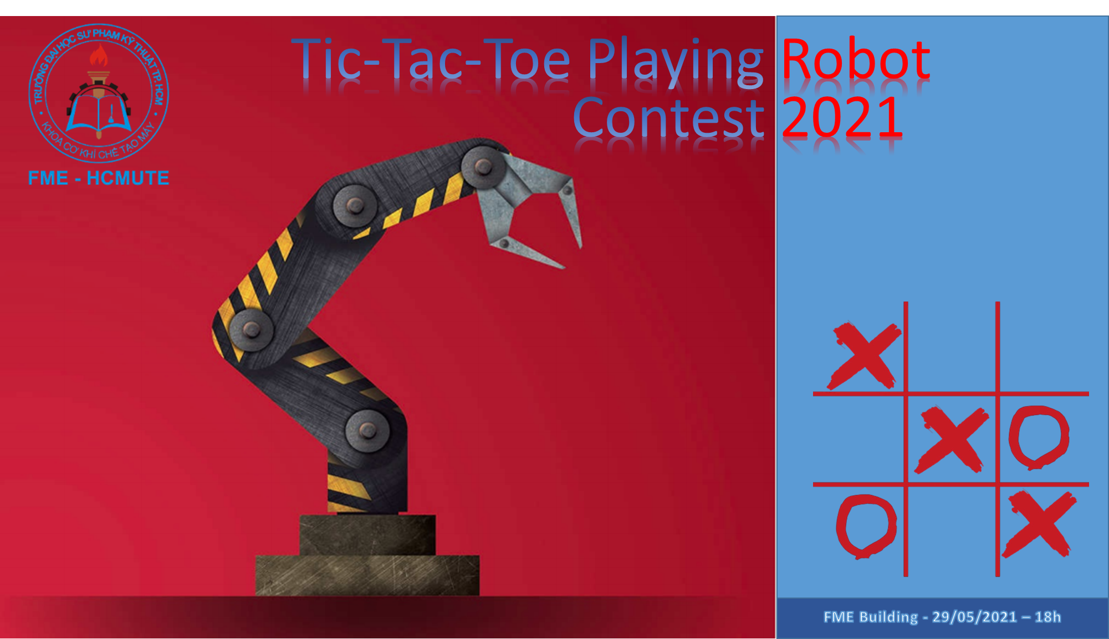
Expenditure:
TABLE OF EXPENDITURE ESTIMATED ROBOT CONTEST 2021
- Robots exhibition stages: 1.000.000đ
- Ads banner, poster for the contest: 1.000.000đ
- Welcome show, MC: 1.000.000đ
- Flowers and gifts for sponsors, guests, judges: 1.000.000đ
- Prizes
First prize 5.000.000 đ x 01
02 First runner-up prizes 3.000.000 đ x 02
03 Second runner-up prizes 2.000.000 đ x 03
06 Incentive prizes 1.000.000đ x 06
Total 27.000.000đ

Organizing Committee
- Chief of Organizing Committee: Prof, Dr. Nguyen Truong Thinh - Dean of Faculty of Mechanical Engineering
SPONSOR:
The organizer proudly presents to businesses, organizations and individuals concerned and sponsor the contests with courtesy.
    - Form of sponsor
EXCLUSIVE sponsors for the contest
    - Sponsor’s benefits
      - Showing sponsor’s logo on contest’s backdrop
      - Showing sponsor’s logo on contest’s banner, brochures
      - Special guests
      - Right of using contest image for purpose of communication, marketing and advertising
      - Awarding in the final
      - Organizer say thanks and gives flowers in the final

In addtion if the sponsor has sholarships or gitfs in kind, you can contact with the organizer as soon as possible. The name of the scholarships, gifts and brand of sponsor will appear with information about the award in means to promote the image for the contest.
The organizers are committing to strictly comply with the rights of branding as well as product introduction for units in the rights attached list.
We hope to receive timely feedback and precious support from your company. Again, sincerely thank you and wish wish you futher success in your business in the future.

Best regards!
For more information please contact the Contest Organizing Committee unit
“ TIC-TAC-TOE PLAYING ROBOT” 2021
The representative: Nguyễn Trường Thịnh
Tel: 0903.675.673
Email: thinhnt@hcmute.edu.vn

Head of Organization Board

Prof, PhD. Nguyen Truong Thinh

Thái Phi

